# Setting Up Application Environment

**Create an Account in Sendgrid**

|  |  |
| --- | --- |
| **Date** | **24 OCT 2022** |
| **Team ID** | **PNT2022TMID30749** |
| **Project Name** | **SKILL AND JOB RECOMMENDER APPLICATION** |
| **Team Members:** | **Bavadharshini, Harishni, Madhumitha A, Madhumitha K, Monisha** |

# STEP 1:

Go to official Sendgrid website: [**https://sendgrid.com/**](https://sendgrid.com/), then click start for free.



# STEP 2:

Then go to Registration Page, you need to give all the details required for creating a Sendgrid account and finally click create button. The below screenshot will show the registration Process.

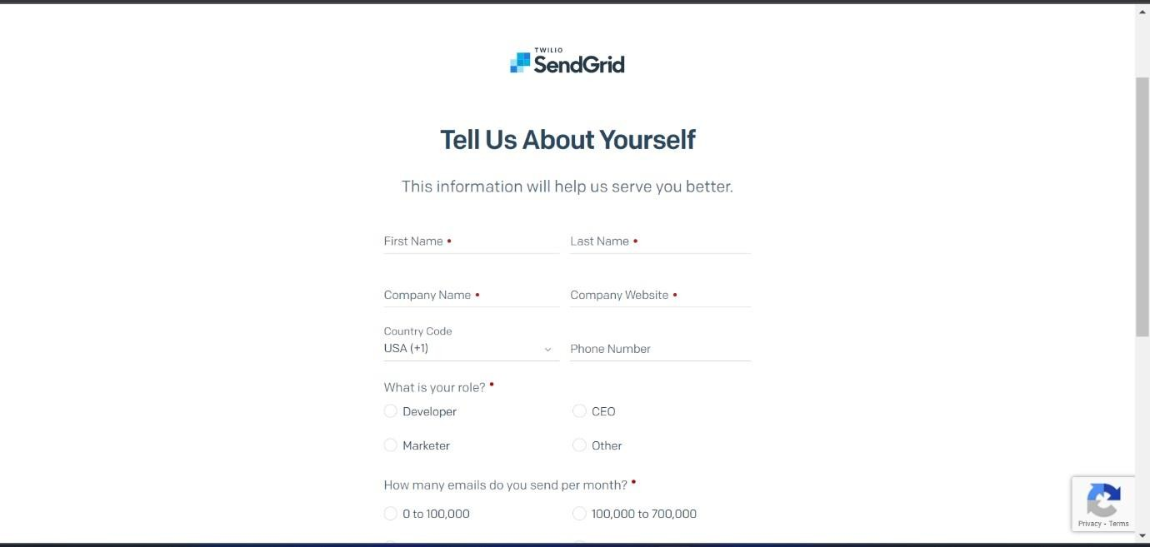

# STEP 3:

Then it will redirect you to a home page of your sendgrid account.

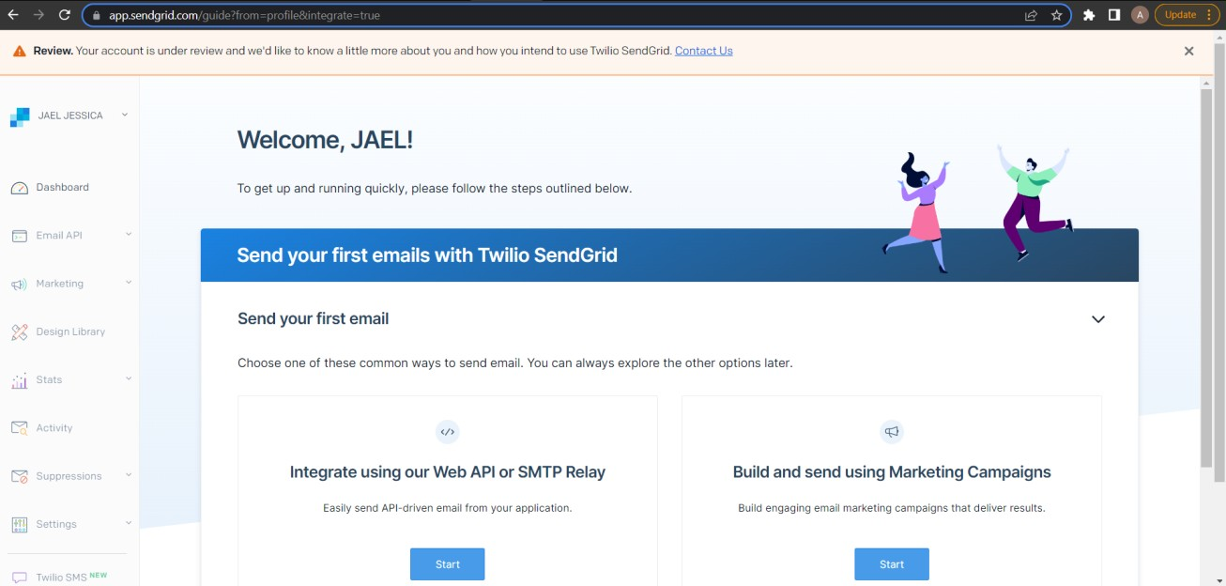

# STEP 4:

Finally, you have created your account and now you can access the sendgrid account.